1.1
Connection between Sales and Date tables activated.
1.2
Two slicers with search enabled for the same data – list and dropdown.
Also a custom visualization – word cloud. English product name inserted.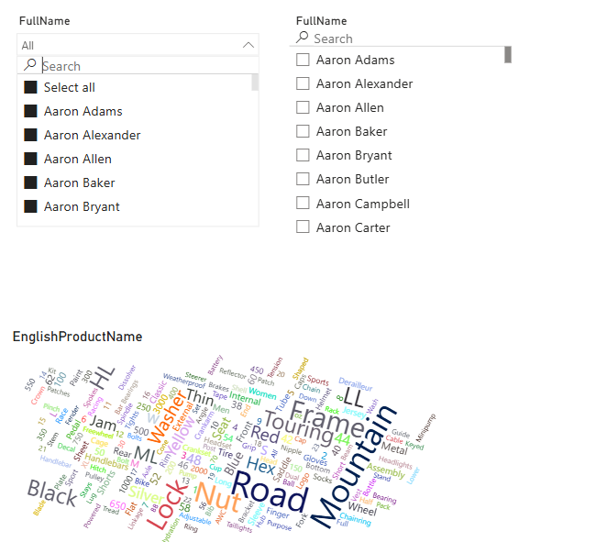

2.2
1. Logo and company name added.
2. Three slicers added – Drop-down country, customer list, order date.
3. 5 regular visuals:
1)Stacked column chart – count of orders by category.
2)Clustered bar chart – count of orders by subcategory. Top 5 subcategories filtered by order count.
3)Cards – showing total revenue and order count.
4)Pie Chart - order Count by promotion.
5)Lines chart – order count and revenue over time.
The two custom visuals work together: the Word Cloud emphasizes frequently occurring terms in top-selling product names, and the text filter enables users to analyze performance based on selected keywords.
4. Interaction disabled between customer slicer and Word Cloud, text filter.
5. Wouldn’t call this report visually appealing, but it is visually consistent.
6. Map added.
7. Mobile layout changed to keep everything readable and in meaningful order.
8. Shared to service portal.
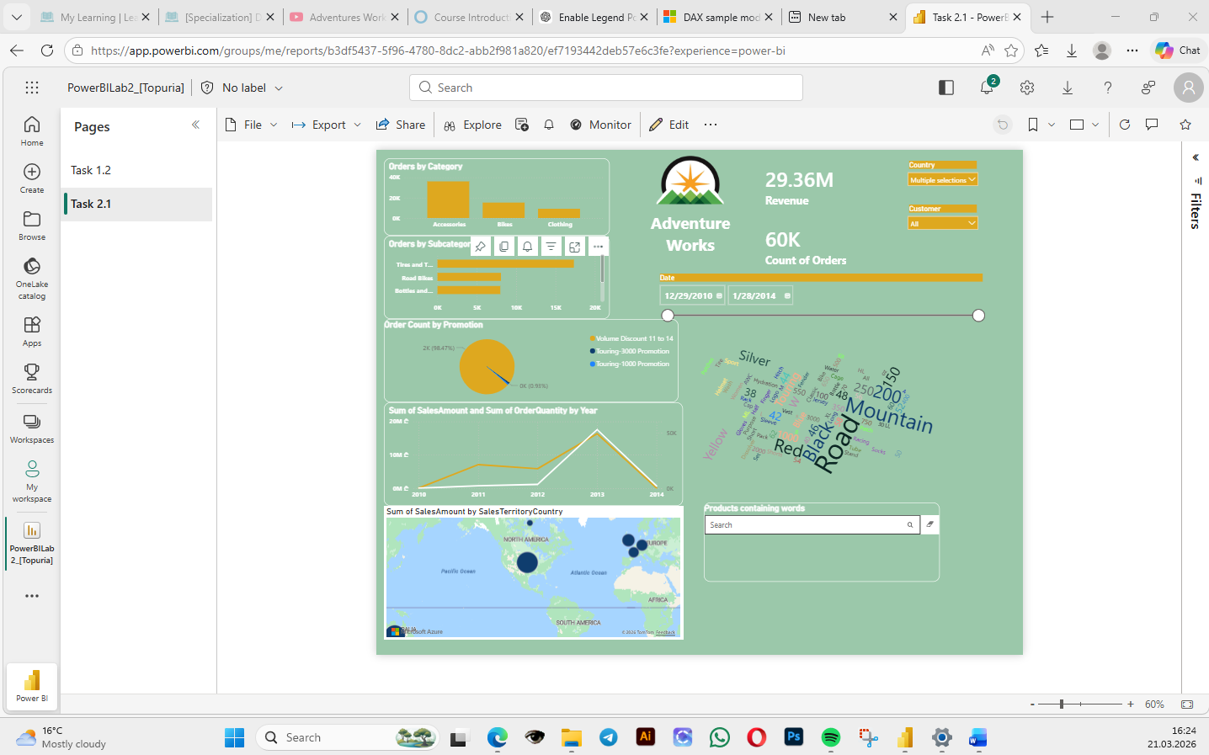
9. Couldn’t sign in to epam account, first time password required, usually I use authenticator.
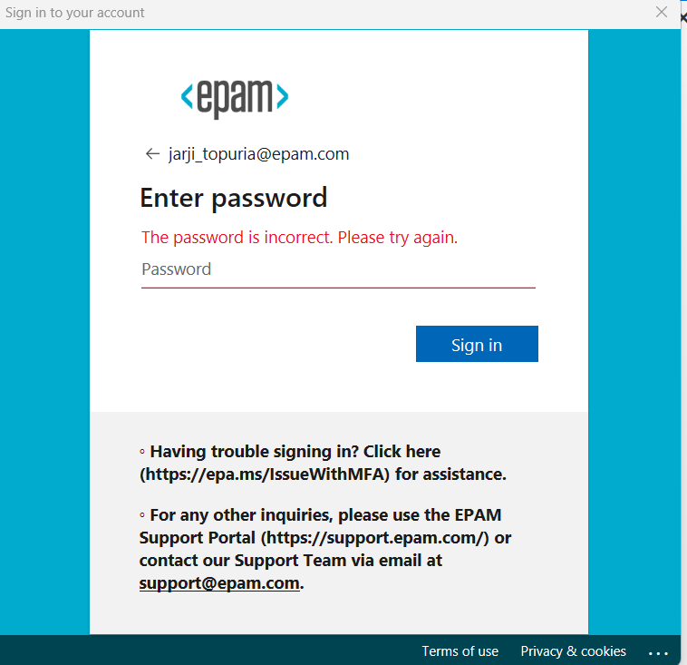
10. Paywall on sharing
